EXHIBIT "Q"

EXHIBIT Q-PAGE 1 OF 3

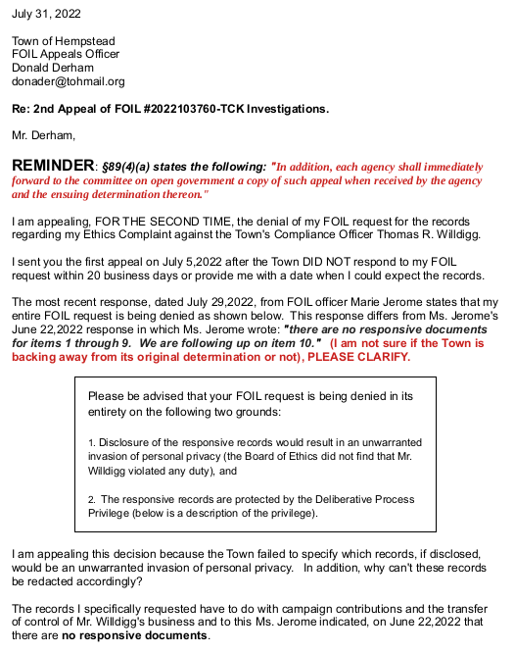
EXHIBIT Q-PAGE 2 OF 3


EXHIBIT Q-PAGE 3 OF 3

